

Cab fare prediction

Analysis and Model Generation in Python and R



June 20, 2019

k Venkata charan

Table of Contents

1. Introduction 3

1.1.Problem Statement 3

2. Data Pre-processing 3

2.1 Data 3

2.2. Data Size and Structure: 3

2.3. Feature Enginering: 4

4

2.4. Completeness of data: 4

2.5.Outlier Analysis 5

2.6. Correlation Plot 6

3. Visualization 8

Pickup Month vs Fare Amount 8

Pickup Month vs Fare Amount 9

Pickup day of week vs Fare Amount 10

Pickup Hour vs Fare Amount 11

How does Number of passengers affect Fare time 12

4. Model Generation 13

4.1. Building a Baseline Model and Identifying a good ML algorithm for this problem 13

4.2. Linear Regression Model 14

4.3. Building Random Forest Model 16

16

4.4.LGB Model 17

4.5 XGB Model 19

XGBoost Working 19

4.5.1. RMSE of four models 20

4.5.1. Tuning XGB 21

5. Final Prediction 23

23

6. Reference s 23

# **1. Introduction**

## **1.1.Problem Statement**

You are a cab rental start-up company. You have successfully run the pilot project and now want to launch your cab service across the country. You have collected the historical data from your pilot project and now have a requirement to apply analytics for fare prediction. You need to design a system that predicts the fare amount for a cab ride in the city.

# **2. Data Pre-processing**

## **2.1 Data**

There are 7variables in our data in which 6 are independent variables and 1 (fare_amount) is dependent variable.

Variables Information:

·  pickup_datetime - timestamp value indicating when the cab ride started.

·  pickup_longitude - float for longitude coordinate of where the cab ride started.

·  pickup_latitude - float for latitude coordinate of where the cab ride started.

·  dropoff_longitude - float for longitude coordinate of where the cab ride ended.

·  dropoff_latitude - float for latitude coordinate of where the cab ride ended.

·  passenger_count - an integer indicating the number of passengers in the cab ride.

.fare_amount – an float indicating fare of an ride

## **2.2. Data Size and Structure:**

Size: 16067 obs. of 7 variables:

Raw Structure:

|  |  |
| --- | --- |
| **VARIABLES** | **DATA TYPE** |
| fare_amount | non-null object |
| pickup_datetime | non-null object |
| pickup_longitude | non-null float64 |
| pickup_latitude | non-null float64 |
| dropoff_longitude | non-null float64 |
| dropoff_latitude | non-null float64 |
| passenger_count | non-null float64 |

## **2.3. Feature Enginering:**

Feature engineering is the process of using domain knowledge of the data to create features that make machine learning algorithms work.

1. Using pickup_datetime we extracted following features

* **pickup_date**
* **pickup_day**
* **pickup_hour**
* **pickup_month**
* **pickup_year**
* **pickup_day_of_week'**



1. Using the pickup and drop-off coordinates we calculate the trip distance in miles based on Haversine Distance.

# 

## **2.4. Completeness of data:**



## **2.5.Outlier Analysis**

Outliers are extreme values that deviate from other observations on data , they may indicate a variability in a measurement, experimental errors or a novelty. In other words, an outlier is an observation that diverges from an overall pattern on a sample.

Let’s plot a box to check any outliers are present in data

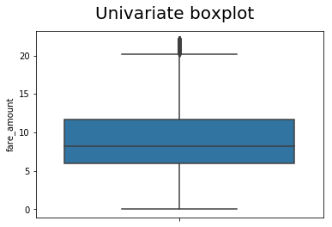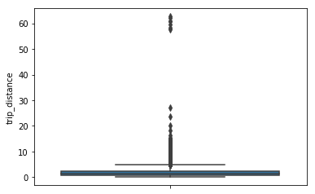

 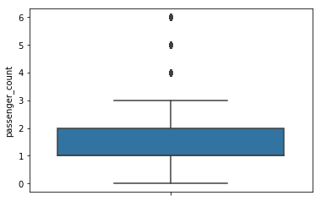

* Here no of passengers is 1 and trip distance is 3.2 miles but fare is 54343
* Here passengers count is 5345.0 and trip distance is 1.5 miles but fare is 8.0

There are max of 6 passengers in test data so lets remove records having passengers count more than 6 .We will use KNN imputation to impute other outliers.

## **2.6. Correlation Plot**

Before performing any type of modelling we need to assess the importance of each predictor variable in our analysis. There is a possibility that many variables in our analysis are not important at all to the problem of class prediction. We cannot use all the features because some features may be carrying the same information or irrelevant information which can increase overhead. To reduce overhead we adopt feature selection technique to extract meaningful features out of data. This in turn helps us to avoid the problem of multi collinearity. In this project we have selected Correlation Analysis for numerical variable and ANOVA (Analysis of variance) for categorical variable.

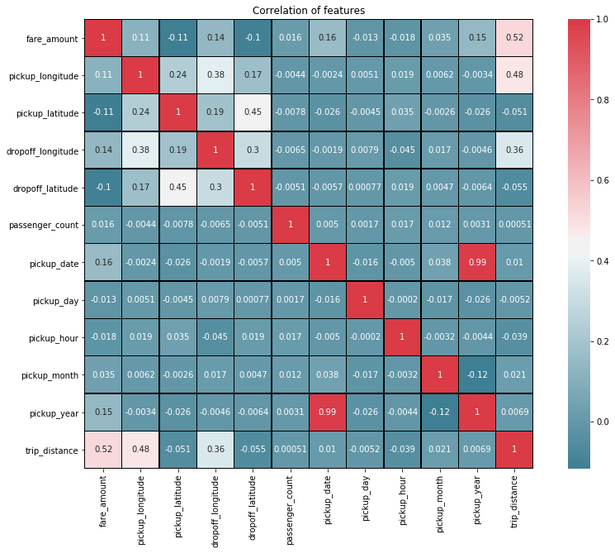

# **3. Visualization**

Let us now look at datetime features and their relationship with Fare Amount

### Pickup Month vs Fare Amount

## 

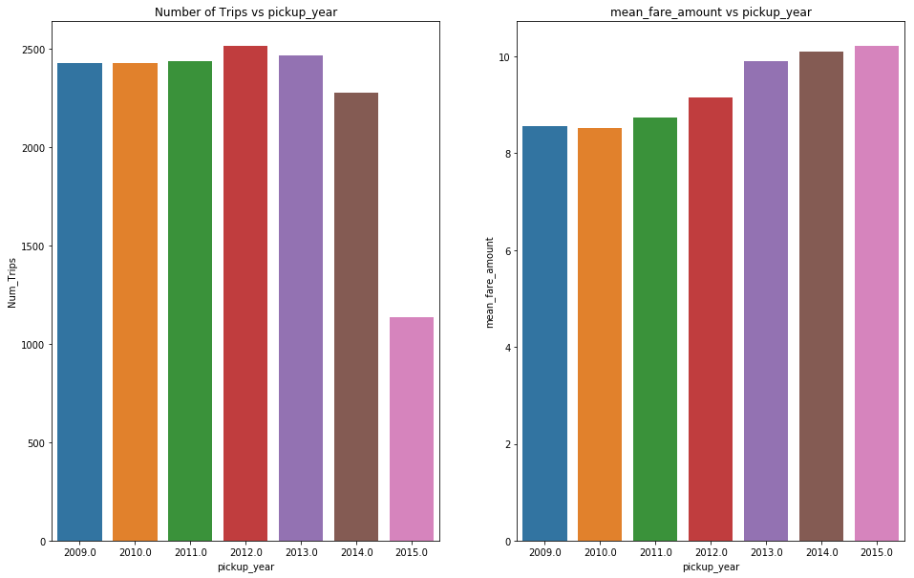

* Avg Fare amount has been increasing over the years.

### 

### Pickup Month vs Fare Amount

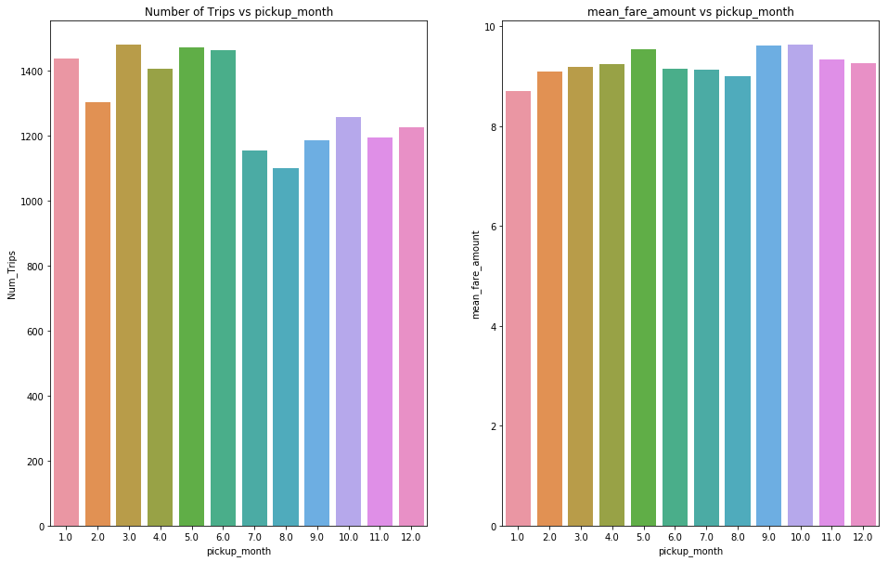

Fares across months are fairly constant, though number of trips are lower from june to decemeber

### Pickup day of week vs Fare Amount

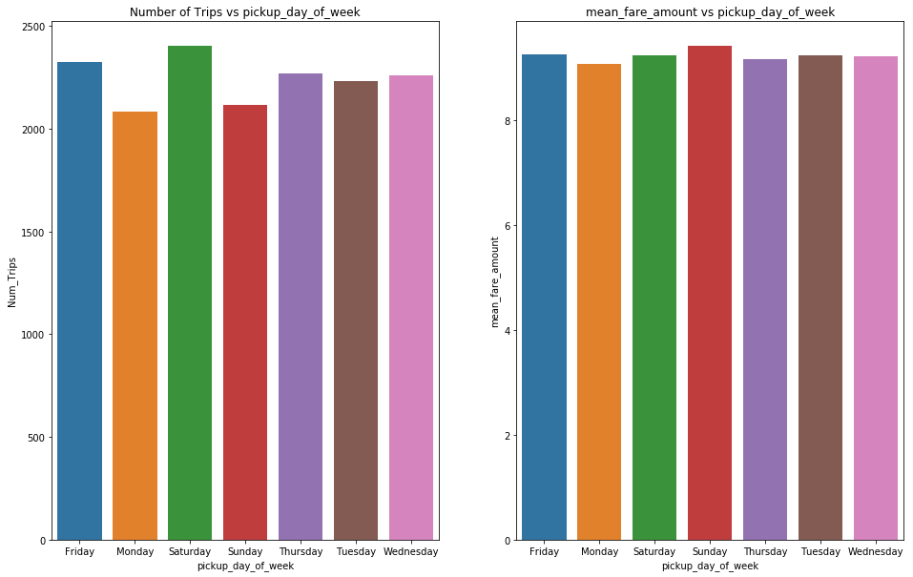

Saturday has low avg fare amount, compared to other days though there are a lot of trips of saturday. On sunday and monday though the number of trips are lower, avg fare amount is higher

### Pickup Hour vs Fare Amount

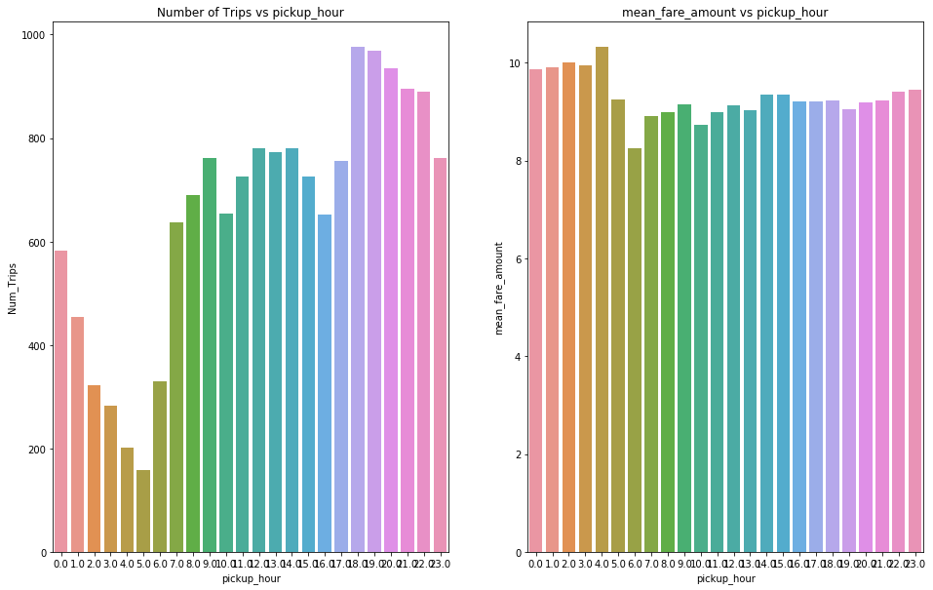

The avg fare amount at 4am and 5 am are the higher while the number of trips at 4 am and 5 am are the least. The number of trips are highest in 18 and 19 hours

### How does Number of passengers affect Fare time

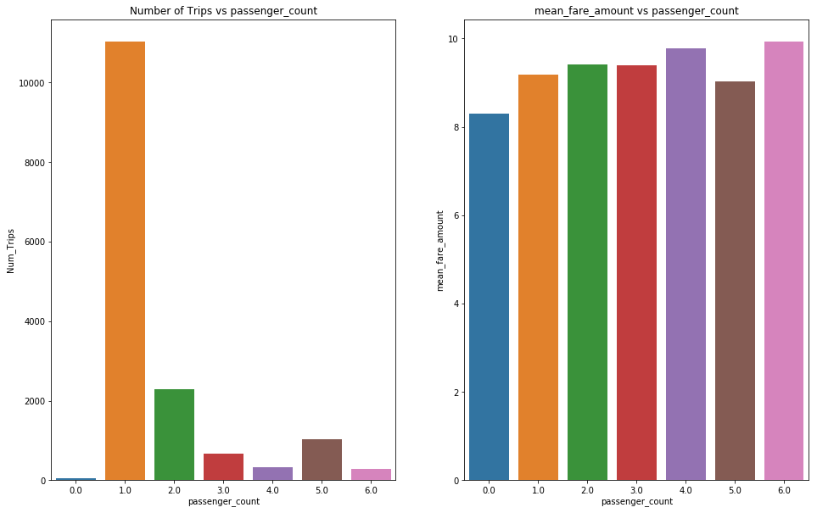

1. There are trips with 0 passengers as well. In these cases are drop and pickup location the same? If so it would mean that passenger didnt take the cab after the cab arrived and a cancellation fee was charged - there were 56 such records.
2. Fare amount is higher for 6 passengers .no of trips for 6 passengers is very low -there were 295 records

# **4. Model Generation**

We will build four models for prediction and will pick the model with lower RMSE score.

we will consider the following ML algorithms:

* Linear Regression
* Random Forest
* Light GBM
* XGBoost

Except for Linear Regression, the rest of the models are ensembles of decision trees, but they differ in the way the decision trees are created. Before we discuss further, let us understand the definitions of a couple of key terms we will be using.

1. **Bagging**: In this method, multiple models are created, and the output prediction is the average predictions of the different models. In Bagging, you take bootstrap samples (with replacement) of your data set and each sample trains a weak learner. Random Forest uses this method for predictions. In Random Forest, multiple decision trees are created, and the output is the average prediction by each of these trees. For this method to work, the baseline models must have a lower bias (error rate).
2. **Boosting**: In this method, multiple weak learners are ensembled to create strong learners. Boosting uses all data to train each learner. But instances that were misclassified by the previous learners are given more weight, so that subsequent learners can give more focus to them during training. XGBoost and Light GBM are based on this method. Both of them are variations of the Gradient Boosting Decision Trees (GBDTs). In GBDTs, the decision trees are trained iteratively — i.e., one tree at a time. XGBoost and Light GBM use the **leaf-wise** growth strategy when growing the decision tree. When training each decision tree and splitting the data, XGBoost follows level-wise strategy, while Light GBM follows leaf-wise strategy.

The metric used in this problem is RMSE. We will try four models - Linear Regression, Random Forest ,LGB and XGBoost and see which model performs better. We will use the best model among the three to further tune and apply feature Engineering

## **4.1. Building a Baseline Model and Identifying a good ML algorithm for this problem**

A baseline model is a solution to a problem without applying any machine learning techniques. Any model we build must improve upon this solution. Some ways of building a baseline model are taking the most common value in case of classification, and calculating the average in a regression problem.

In this analysis, since we are predicting fare amount (which is a quantitative variable )— we will predict the average fare amount.

For Baseline, we will predict the average fare amount and check the RMSE on validation data. Any model, should be able to beat this simple benchmark

**This resulted in an RMSE of 4.20. So any model we build should have an RMSE lower than 4..20.**



## **4.2. Linear Regression Model**

**Linear Regression**: It is used to find a linear relationship between the target and one or more predictors. The main idea is to identify a line that best fits the data. The best fit line is the one for which the prediction error is the least. This algorithm is not very flexible, and has a very high bias. Linear Regression is also highly susceptible to outliers as it tries to minimize the sum of squared errors.

The simplest form of the regression equation with one dependent and one independent variable is defined by the formula

y = c + b*x,

where y = estimated dependent variable score,

c = constant,

b = regression coefficient, and

x = score on the independent variable.



Test RMSE for Linear Regression is 3.4730594059797135

Train RMSE for Linear Regression is 3.46797934693488

Variance for Linear Regression is 0.00508005904483344

RMSE for Linear Regression is 3.4730594059797135

**The test RMSE for Linear Regression model was 3.473, and the training RMSE was 3.467.** This model is an improvement on the baseline prediction. Still, the error rate is very high in this model, though the variance is very low (0.005). Let’s try a more complex model next.

The linear regression model performed better than than the Baseline Mode. Let us create a Random Forest Model and see how it performs. Reason for failure of linear regression model, is that it tries to fit a linear line between the variables and the target. But, as we saw in the Exploratory analysis phase this is not true.

## **4.3. Building Random Forest Model**

The random forest combines hundreds or thousands of decision trees, trains each one on a slightly different set of the observations, splitting nodes in each tree considering a limited number of the features. The final predictions of the random forest are made by averaging the predictions of each individual tree.

Random Forest works on the principle of Bagging The idea behind this is very intuitive- when we want to make a decision about a field we do not know about we take advice from a people and then we decide based on the majority opinion. This is the idea behind Random Forest - multiple decision trees are created and output from each of the trees are averaged to predict the value. Random Forest are not susceptible to overfitting and since in Random Forest, each tree is trained independently of the other, it is more robust.

## 

**The Random Forest model gave an RMSE of 2.33 on validation data and train RMSE of 0.875 .** There is a huge variation in the training and validation RMSE, indicating overfitting. To reduce overfitting, we can tune this model.

Random Forest has reduced the RMSE considerably as compared to Linear Regression.

The next type of algorithm we will see is also another Tree based Ensemble algorithm - but it follows concept of Boosting.

## **4.4.LGB Model**

**What is Light GBM?**

Light GBM is a gradient boosting framework that uses tree based learning algorithm.

**How it differs from other tree based algorithm?**

**Light GBM grows tree vertically** while other algorithm grows trees horizontally meaning that Light GBM grows tree leaf-wise while other algorithm grows level-wise. It will choose the leaf with max delta loss to grow. When growing the same leaf, Leaf-wise algorithm can reduce more loss than a level-wise algorithm.

Below diagrams explain the implementation of LightGBM and other boosting algorithms.

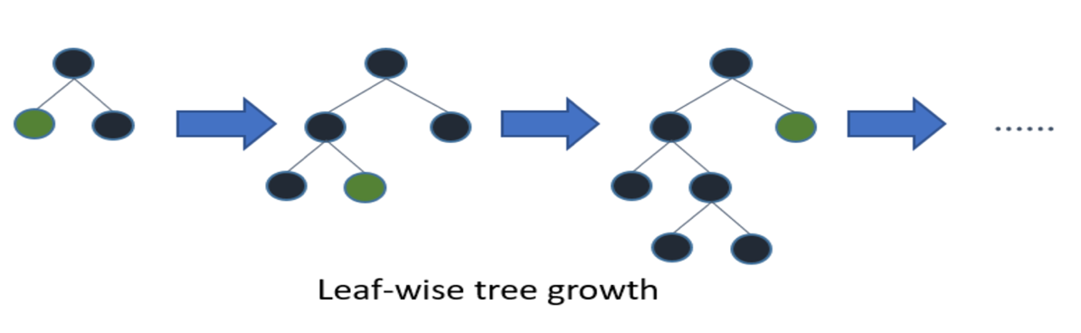

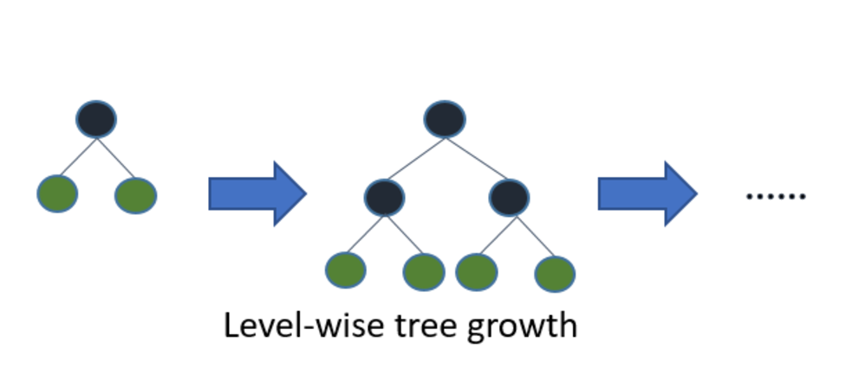



This model gave an RMSE of 2.31 on validation data but the bias is higher than Random Forest. On the other hand, the variance of this model was 2.25

as compared to 1.45 in our Random Forest model.

|  |
| --- |
|  |

Light GBM is better than Random Forest . Let us also create a XGBOOST Model and see how it performs.  It is not advisable to use LGBM on small datasets. Light GBM is **sensitive to overfitting** and can easily overfit small data.

## **4.5 XGB Model**

XGBoost (**Ex**treme **G**radient **Boost**ing) is an optimized distributed gradient boosting library. Yes, it uses gradient boosting (GBM) framework at core. Yet, does better than GBM framework alone. It is used for supervised ML problems.

XGBoost is the most popular machine learning algorithm these days. Regardless of the data type (regression or classification), it is well known to provide better solutions than other ML algorithms

## XGBoost Working

XGBoost belongs to a family of boosting algorithms that convert weak learners into strong learners. A weak learner is one which is slightly better than random guessing. Let's understand **boosting first** (in general).

Boosting is a sequential process; i.e., trees are grown using the information from a previously grown tree one after the other. This process slowly learns from data and tries to improve its prediction in subsequent iterations

k-fold Cross Validation using XGBoost

In order to build more robust models, it is common to do a k-fold cross validation where all the entries in the original training dataset are used for both training as well as validation. Also, each entry is used for validation just once. XGBoost supports k-fold cross validation via the cv() method. All you have to do is specify the nfolds parameter, which is the number of cross validation sets you want to build. Also, it supports many other parameters (check out this link) like:

* num_boost_round: denotes the number of trees you build (analogous to n_estimators)
* metrics: tells the evaluation metrics to be watched during CV
* as_pandas: to return the results in a pandas DataFrame.
* early_stopping_rounds: finishes training of the model early if the hold-out metric ("rmse" in our case) does not improve for a given number of rounds.
* seed: for reproducibility of results.



### 

# **4.5.1. RMSE of four models**

**Mean Absolute Error (MAE):** MAE measures the average magnitude of the errors in a set of predictions, without considering their direction. It’s the average over the test sample of the absolute differences between prediction and actual observation where all individual differences have equal weight.

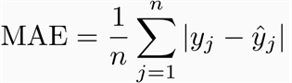

If the absolute value is not taken (the signs of the errors are not removed), the average error becomes the Mean Bias Error (MBE) and is usually intended to measure average model bias. MBE can convey useful information, but should be interpreted cautiously because positive and negative errors will cancel out.

**Root mean squared error (RMSE):** RMSE is a quadratic scoring rule that also measures the average magnitude of the error. It’s the square root of the average of squared differences between prediction and actual observation.

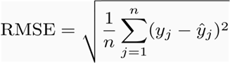

Taking the square root of the average squared errors has some interesting implications for RMSE. Since the errors are squared before they are averaged, the RMSE gives a relatively high weight to large errors. This means the RMSE should be more useful when large errors are particularly undesirable.

For each of the model we have built above, let us see what is the train RMSE and test

RMSE - This will help us understand variance in the model and get the best mode



We can see that there is a very high difference in the train and test RMSE for Random Forest, though overall the test-rmse of Random Forest is the best. Very high variance is a sign of overfitting. XGBOOST has done slightly better than Light GBM in terms of training and test rmse - and variance is higher in XGBOOST In further work, we will consider XGBOOST as the model and add features and tune this model

# **4.5.1. Tuning XGB**

XGBoost parameters can be divided into three categories (as suggested by its authors):

General Parameters: Controls the booster type in the model which eventually drives overall functioning

Booster Parameters: Controls the performance of the selected booster

Learning Task Parameters: Sets and evaluates the learning process of the booster from the given data

* learning_rate: step size shrinkage used to prevent overfitting. Range is [0,1]
* max_depth: determines how deeply each tree is allowed to grow during any boosting round.
* subsample: percentage of samples used per tree. Low value can lead to underfitting.
* colsample_bytree: percentage of features used per tree. High value can lead to overfitting.
* n_estimators: number of trees you want to build.
* objective: determines the loss function to be used like reg:linear for regression problems, reg:logistic for classification problems with only decision, binary:logistic for classification problems with probability



Best params after tuning

{'colsample_bytree': 0.7,

'learning_rate': 0.03,

'max_depth': 6, 'min_child_weight': 4,

'n_estimators': 500, 'objective':

'reg:squarederror', 'subsample': 0.8}



RMSE for XGBOOST After Tuning is 2.263933879882796.

Parameter tuning significantly improved the predictive ability of our Machine Learning model. Another way to improve the model’s accuracy is to increase the amount of training data, and/or building ensemble models. If we have a lot of dimensions (features) in the data, dimensionality reduction techniques can also help improve the model’s accuracy.

# **5. Final Prediction**

# 

# 

# **6. Reference s**

* https://www.analyticsvidhya.com/blog/2016/01/xgboost-algorithm-easy-steps/
* <https://www.kaggle.com/aniruddhachakraborty/lasso-gbm-xgboost-top-20-0-12039-using-r>
* https://medium.com/@pushkarmandot/https-medium-com-pushkarmandot-what-is-lightgbm-how-to-implement-it-how-to-fine-tune-the-parameters-60347819b7fc